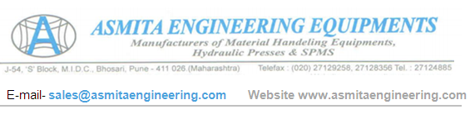
QUOTATION
To Nihva Support r.kulkarni@nihva.com | Quot.No. – 1701113
To Nihva Support r.kulkarni@nihva.com | Date – 13 Nov-2017

Kind Attn- Mr. Kulkarni-91 8551094333
Dear Sir,
Thank you for you enquiry, we are pleased to submit our quotation for –

MODEL | MANUAL SCISSOR TROLLEY
Capacity | 500 kg | 1000Kg
Size | 810mm L X 500mm W | 1000mm L X 510mm W
Max HT. | 900 mm | 1000 mm
Min Height | 350 mm | 450 mm
Firm PRICE | RS. 35,000/- for MS | RS. 38,000/- for MS
*Dimension Unit - All Measurements in mm

TERMS & CONDITIONS : -
1. TAXES –GST@28%
2. Delivery - Immediately after Payment
3. 100% Advance With Purchase Order , Against Proforma Invoice
4. Transportation and unloading to buyers accounts
5. Six Month Warranty Against Faulty Workmanship
6. If The Order Is Cancelled Payment Will Be Forfieted.
We look forward for your valued order & assure you our best service.

Thanking You,
Best Regards
For ASMITA ENGINEERING EQUIPMENTS,

Miss.-Vandana Jadhav (7720002865)



